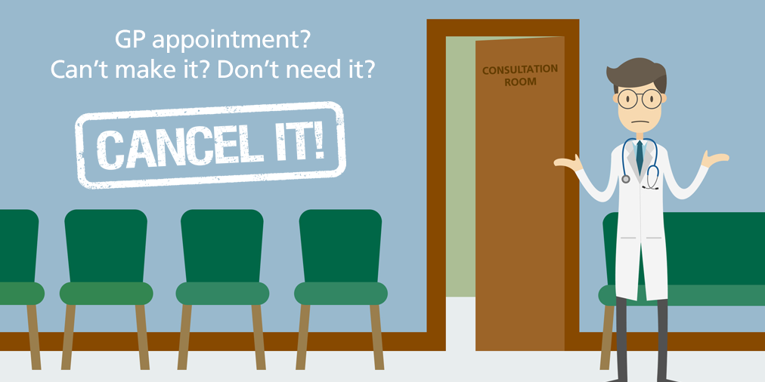

Due to an increase in the number of wasted appointments through patients failing to attend appointments without informing the surgery, it has become necessary to implement the following policy:

If you repeatedly fail to attend appointments you may be removed from this practice list and required to find an alternative doctor.

If you cannot attend your appointments for any reason please let us know as soon as possible, giving at least 24 hours notice. We can then offer the appointment to someone else.

Thank you for your co-operation

